Name __________________________________ Period ____ Date ___
MCAS Review --- 1st half of the year
Phys Sci. 10) Differentiate between physical changes and chemical changes.

1. Which of the following is an example of a physical change?
A. lighting a match
B. breaking a glass
C. burning of gasoline
D. rusting of iron

2. In making a pizza, which process involves a chemical change?
A. mixing spices for the sauce
B. slicing pepperoni for the topping
C. spreading cheese on the pizza
D. baking the dough to form the crust

3. Which is an example of a chemical change?
A. a rusting car fender
B. a spinning top
C. a spilled bucket of water
D. a melting popsicle.

Phys Sci. 6) Differentiate between an atom and a molecule.

4. What is the smallest particle of the element gold (Au) that can still be classified as gold?
A. atom
B. molecule
C. neutron
D. proton

5. What is the smallest unit of a compound that still can be classified as a compound?
A. atom
B. molecule
C. neutron
D. proton

6. Copper is an element that is used in electrical wires. What is the smallest unit of copper that still maintains the characteristics of copper?
A. the atom
B. the electron
C. the nucleus
D. the proton

Phys Sci. 5) Recognize that there are more than 100 elements that combine in a multitude of ways to produce compounds that make up all of the living and nonliving things that we encounter.

7. A scientist combines oxygen and hydrogen to form water. This combination illustrates that water is
A. an atom
B. an element
c. a mixture
d. a compound

8. Which of the following is formed when two elements combine chemically?
A. An atom
B. a compound
C. an electron
D. a mixture

9. How many different elements are in the compound sodium carbonate (Na₂CO₃)?
A. 1
B. 3
C. 6
D. 7

10. Which of the following models correctly represents the compound phosphorus trichloride (PCl3)?
 | C. | 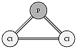
 | D. | 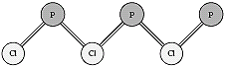

 | A. | 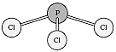
 | B. | 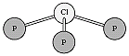

11. A scientists combines oxygen and water to form water. This combination illustrates that water is a
A. atom
B. element
C. mixture
D. compound

Phys Sci. 8) Differentiate between mixtures and pure substances.
12. Which of the following substances can be separated into several elements?
A. nitrogen
B. zinc
C. air
D. aluminum

13. Sulfur (S), oxygen (O2), water (H2O), and sodium chloride (NaCl) are all examples of pure substances. Which of the following describes all pure substances?

A. A pure substance consists of only one type of element.
B. A pure substance has a definite chemical composition.
C. A pure substance cannot be broken down into simpler substances.
D. A pure substance is normally found as a solid at room temperature.

14. Which is the following is an example of a mixture?
A. rust forming on an iron nail
B. sugar crystals dissolving in water
C. sodium and chlorine forming table salt
D. hydrogen and oxygen reacting to produce water.

15. Which of the following illustrations represents a pure substance?
 | C. | 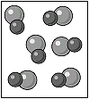
 | D. | 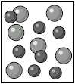

 | A. | 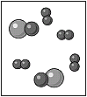
 | B. | 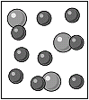

Phys Sci. 2) Differentiate between volume and mass. Define density.

16. The diagram below shows what occurred when a can of diet soda and a can of regular soda were dropped into a container of water. The can of regular soda sank to the bottom of the container, but the can of diet soda floated.
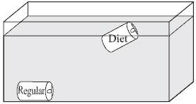
Which of the following statements best explains this observation?

A. The can of regular soda is less dense than the can of diet soda.
B. The can of regular soda is more dense than the can of diet soda.
C. The can of regular soda has a larger volume than the can of diet soda.
D. The can of regular soda has a smaller volume than the can of diet soda.

17. Which of the following units best represents the density of an object?
A. kg
b. hr
c. m/s
d. g/cm³

18. What is the density of an object that has a mass of 10 grams and a volume of 5 cm3?

A. 50 g/cm₃
B. 2 gcm³
C. 0.5 g/cm³
D. 15 g/cm³

19. Which of the following instruments is best to use to measure the volume of a small irregularly shaped solid?

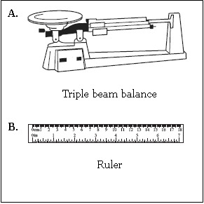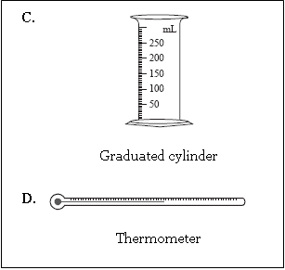

20. Two different bars of soap are being investigated by a group of students. They measured the mass and volume of each bar and recorded the results in the table below.

a) Calculate the density of each bar of soap. Show your work.

Soap Mass (g) Volume (cm³)  A 110 100  B 95 100 |  | Density of water = 1.0 g/cm³

Soap A:

Soap B:

b) The diagram below represents a container of water. Draw and label the positions that soap bar A and soap bar B would occupy if they were placed in this container.

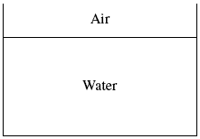

c) Explain why you drew each bar of soap in the position selected.

