**Earth’s Structure REVIEW**

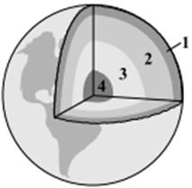

1. Label the different layers of the Earth on the diagram

2. What are the characteristics of each layer of Earth?

a. Layer 1 __________________________

1.

2.

3.

b. Layer 2 ___________________________

1.

c. Layer 3 _________________________

1.

d. Layer 4 _____________________________________________

1.

3. What are tectonic plates?

a. What is the lithosphere?

b. What is the asthenosphere?

5. What are convection currents?

Draw them

Which of the following graphs **best** represents the relationship between density and depth of material? below Earth’s surface?

|  |  |
| --- | --- |
|  |  |
|  |  |

4. Continental drift --- A super continent named Pangaea formed.

Name three pieces of evidence that Pangaea once existed.

1.

2.

3.