Second Packet
Physical Science – What I need to know to ACE the Physical Science Questions on the MCAS.

Differentiate between weight and mass

1 How would the measurable properties of a golf ball change if it were moved from Earth to the Moon?

A. It would have the same mass, but a different weight.
B. It would have the same weight, but a different mass.
C. It would have the same density, but a different mass.
D. It would have the same mass, but a different density.

2. The table below shows the mass and the weight of a certain object on Earth.

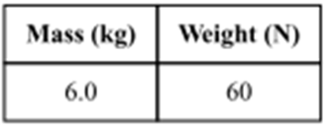
The force of gravity on the Moon is about one-sixth the force of gravity on Earth. What are the approximate mass and approximate weight of the same object on the Moon?

A.  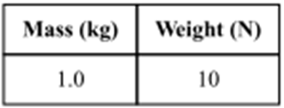 | B  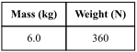 | C  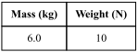 | D  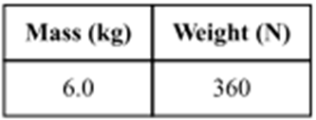

3 Which of the following instruments is best to use to measure the volume of a small irregularly shaped solid?
 | C. | 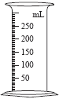  Graduated cylinder
 | D. | Thermometer

A. | 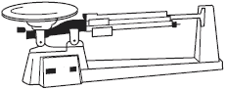  Triple beam balance
B. | Ruler

4. In a laboratory, a sealed container with 100 g of steam is cooled until all the steam becomes a liquid. The container is then cooled further until all the water becomes a solid.
Which of the following remains constant during both of these changes?
A. the mass of the water
B. the pressure in the container
C. the total energy of the water
D. the position of the atoms in the container

5. Suppose 20 g of liquid hydrogen peroxide is heated so it completely breaks down into liquid water and oxygen gas. Which best describes the total mass of the water and oxygen that was produced?

A. more than 20 g because of the addition of heat
B. more than 20 g because there are now two substances
C. less than 20 g because oxygen gas is very light
D. 20 g because no matter is added or removed

Question 6 – answer on a separate piece of paper
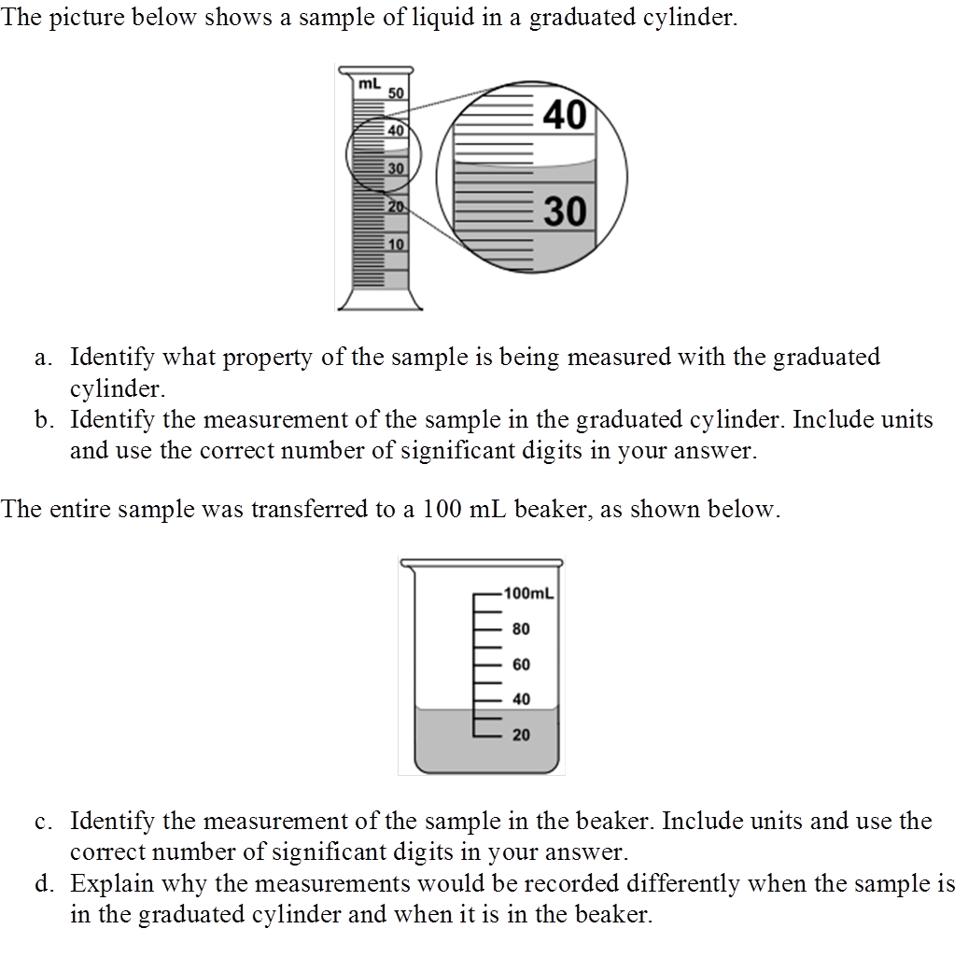

7. A student is given a sample of an unknown liquid to test in the laboratory. The student thinks that the liquid is water. Which of the following physical properties of the sample is the most helpful to determine if the liquid is water.

A. color of the liquid
B. mass of the liquid
C. volume of the liquid
D. Boiling point
8. If 1 kg of the compound toluene melts at −95°C, then 500 g of toluene will

A. melt at −47.5°C.
B. melt at −95°C.
C. boil at 95°C.
D. boil at 47.5°C.

9. The diagram below shows some positions in the path of a pendulum swinging from a fixed point called a
fulcrum.
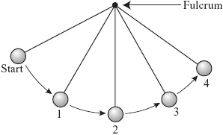
The pendulum is raised to the start position and released. At which two numbered positions is the potential
energy of the pendulum most likely the same?
 | A. | position 1 and position 3
 | B. | position 1 and position 4
 | C. | position 2 and position 3
 | D. | position 2 and position 4

10. An escalator at a shopping mall is 10 m long and moves at a constant speed of 0.5 m/s. If José steps onto the escalator at the bottom while it is moving, how long will it take him to travel the 10 m?
 | A. | 5 s
 | B. | 10 s
 | C. | 15 s
 | D. | 20 s

11. The diagram below shows information about the motion of a toy car between two points on a track.
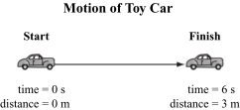

Which of the following can be determined using the information shown in the diagram?
 | A. | the car’s position after the first two seconds
 | B. | the car’s mass as it moves away from the start
 | C. | the car’s average speed between the two points
 | D. | the car’s total acceleration within the first meter

12. What is the formula for speed? ___________
Calculate the toy car’s average speed using the diagram of the Motion of the Toy Car. Show all work!

13. A pot of cold water was heated on a stove until the water boiled. Which of the following best explains why the water was able to boil?
 | A. | The hot stove absorbed cold from the pot.
 | B. | The cold water absorbed heat from the pot.
 | C. | The hot stove gave off heat to the surrounding air.
 | D. | The cold water gave off cold to the surrounding air.

14. A student in a laboratory transfers a beaker containing a hot solution from the lab table to a cool water bath.
Which of the following parts of the system experiences an increase in heat energy?
A. beaker
B. lab table
C. solution
D. water bath

15. Which statement about the molecules in ice and the molecules in liquid water is correct?

A. The molecules in ice have more energy than the molecules in liquid water.
B. The molecules in ice contain different atoms than the molecules in liquid water.
C. The molecules in ice have more electric charge than the molecules in liquid water.
D. The molecules in ice are less free to move than the molecules in liquid water.

16. Which of the following could occur as a result of decreasing the heat energy of a gas?
 | A. | condensation
 | B. | evaporation
 | C. | radiation
 | D. | vaporization
17. A cold can of juice is removed from the refrigerator and is placed outdoors on a warm day. After several minutes, moisture appears on the outside of the cold can. Which of the following statements best explains why the moisture appears?
 | A. | The warm air absorbs cold from the can and changes to a liquid.
 | B. | Water vapor in the air condenses into a liquid on the cold can.
 | C. | The warm air causes heat to flow out of the can and condense in the air.
 | D. | Water vapor in the air absorbs heat from the can and changes to a liquid.
18. When a person’s sweat evaporates, the person feels cooler. Which of the following statements best describes why sweating helps the person feel cool?
 | A. | Heat is absorbed by sweat when it evaporates.
 | B. | Heat is absorbed by the body when sweat evaporates.
 | C. | The temperature of the water in sweat goes down when it evaporates.
 | D. | The temperature of the water in the body goes up when sweat evaporates.

