Name _____________________________________ Date _________________

MCAS REVIEW PACKET Earth Science Questions

ESS#1 Mapping the Earth
Vocabulary words
- Contour lines
- contour interval
- Key
- Scale
- compass

Use the following contour map to answer the following questions

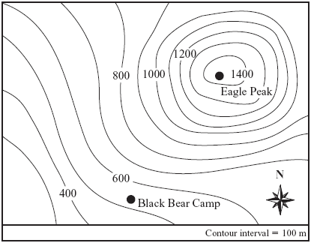

1. What is the approximate elevation of black bear camp? __________________

2. What is the approximate elevation of Eagle Peak camp? _________________

3. What is the elevation of the contour line just above the N? ____________ How do you know?
______________________________________________________________________________

4. What is the contour interval for this map? ___________________ What does that mean?

5. What is the lowest elevation on this map? ___________ Mark its location on the map.

6. Where is the top of the mountain? _________ mark its location on the map.

7. If the contour lines are close together like they are between contour lines 1000 and 1200 what does that tell you?
A. the landscape is steep
B. the landscape is gently sloping or flat
C. It tells you nothing

8. If the contour lines are spaced farther apart like they are between 400 and 600 what does that tell you?

9. What is the best estimate for the for the difference in elevation between Black Bear and Eagle peak>
A. 400m
B. 900m
C 1200m
D. 1500m

10. The diagram below shows a side view of a landform with different elevations.

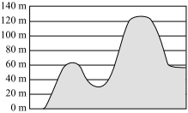
Which of the following maps best represents this landform?

A. | B.
C. | D.

11. How did you get the answer?

